4) STOCK MAINTANANCE

**SEQUENCE DIAGRAM**

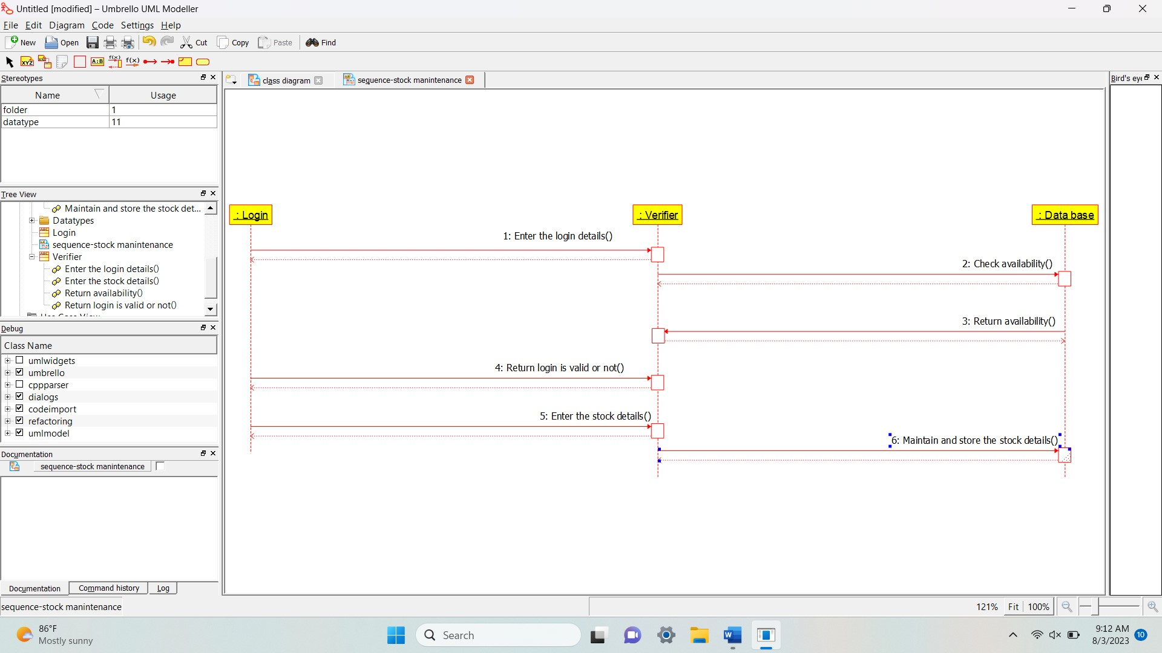

**DEPLOYMENT DIAGRAM**

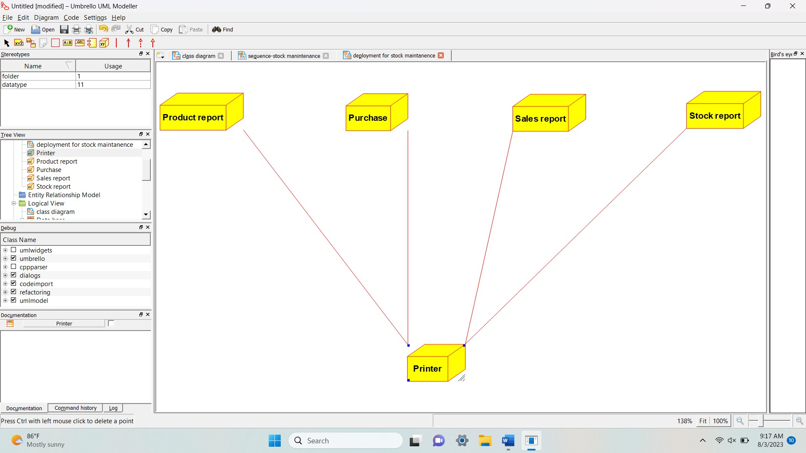

**PACKAGE DIAGRAM**

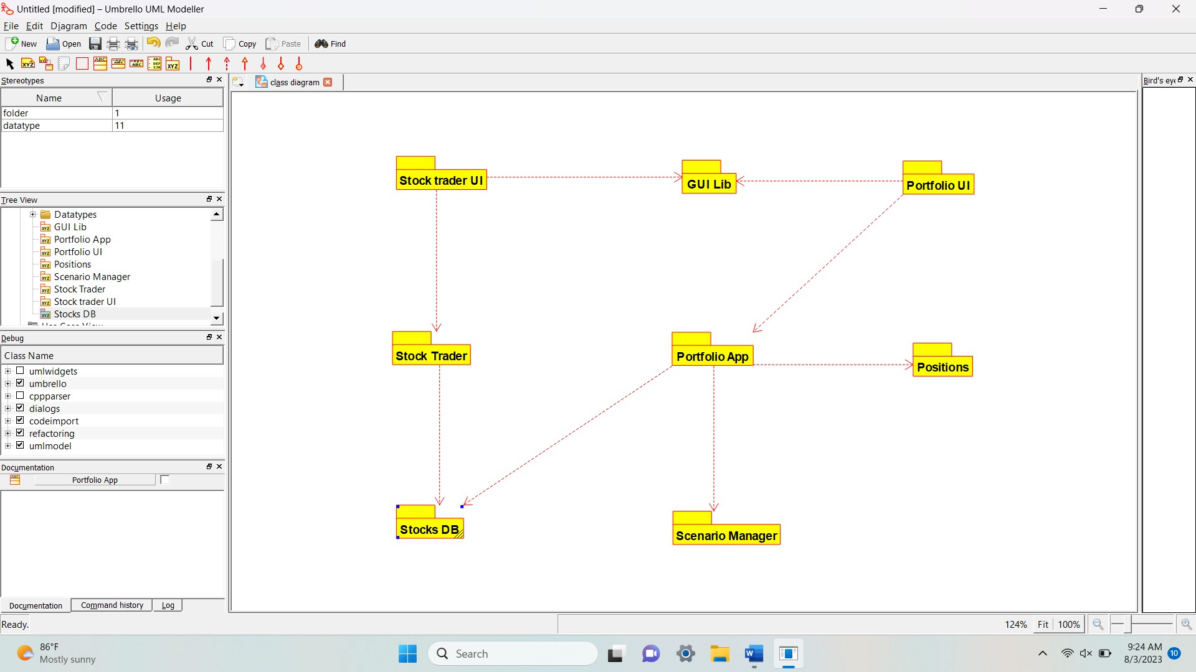

USE CASE DIAGRAM:

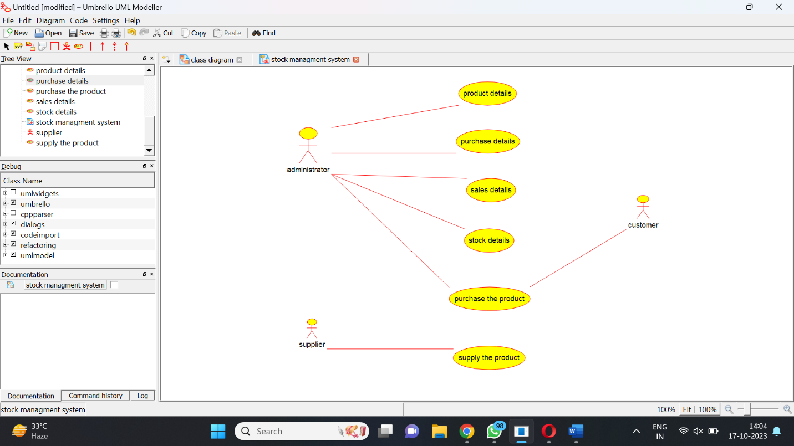

COLLABORATION DIAGRAM:

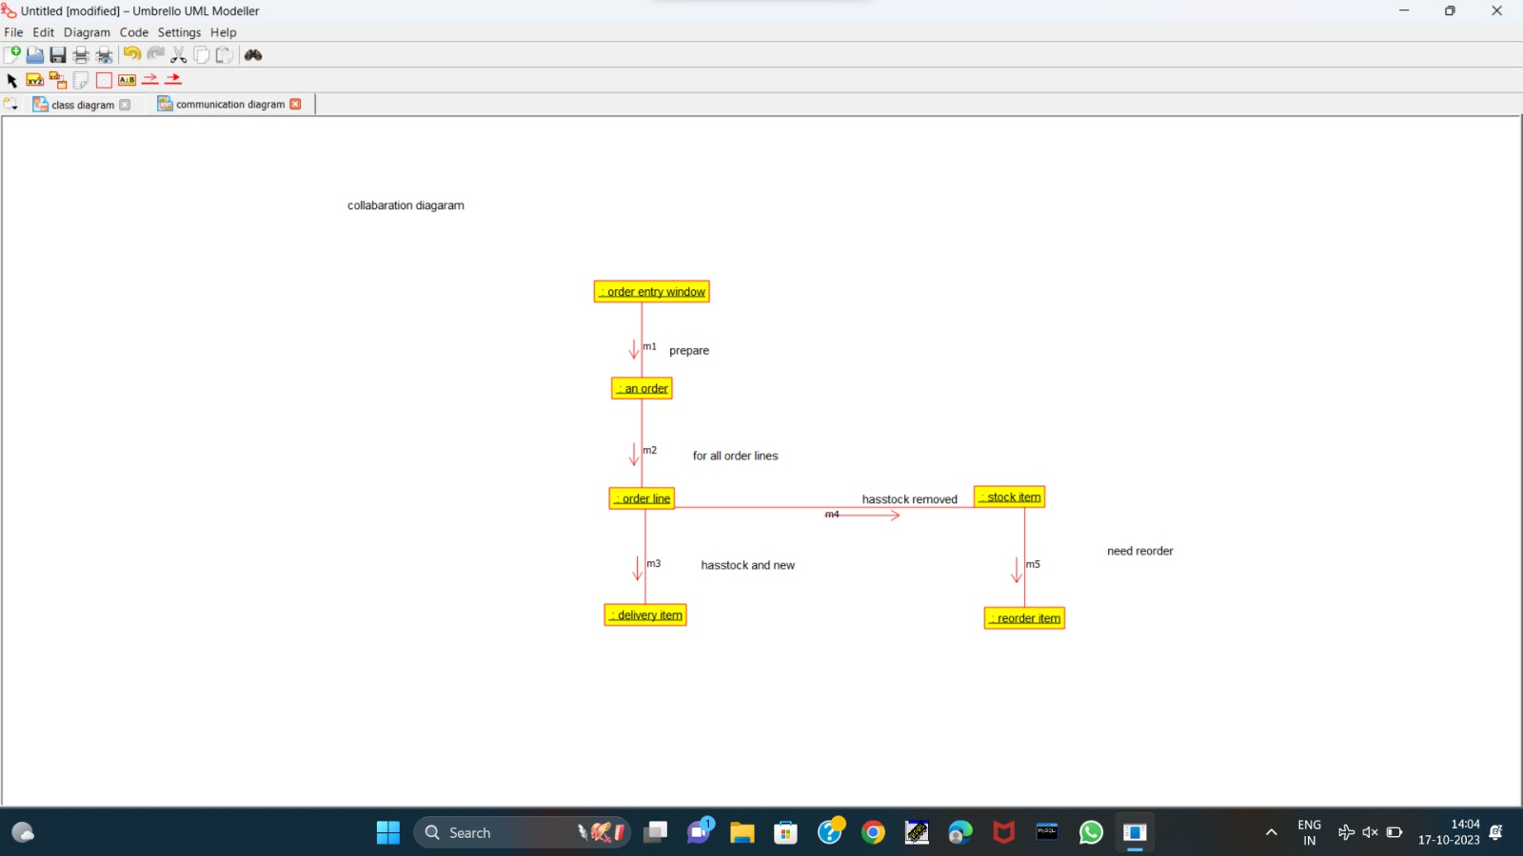

COMPONENT DIAGRAM:

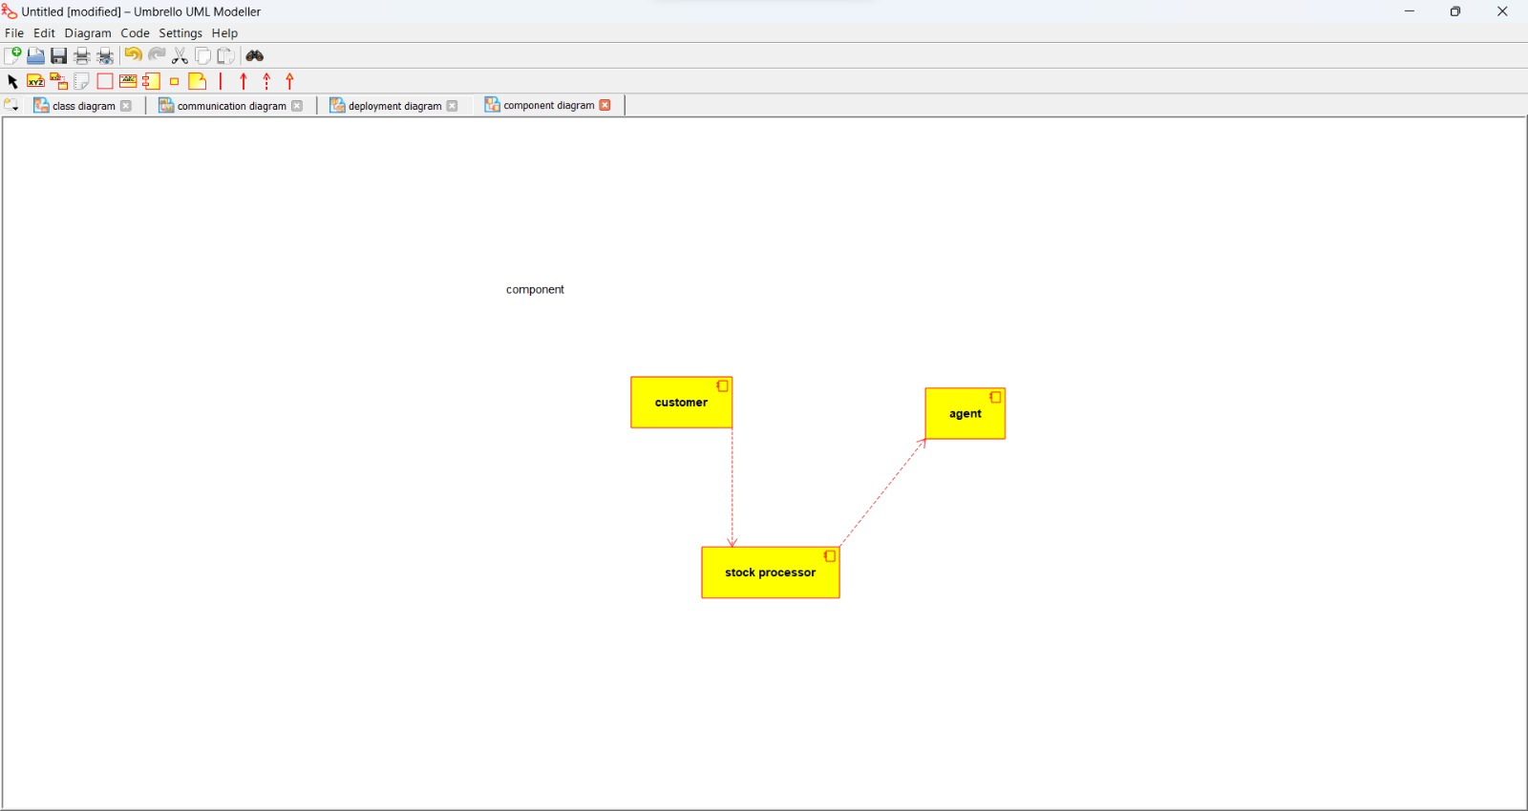

CLASS DIAGRAM:

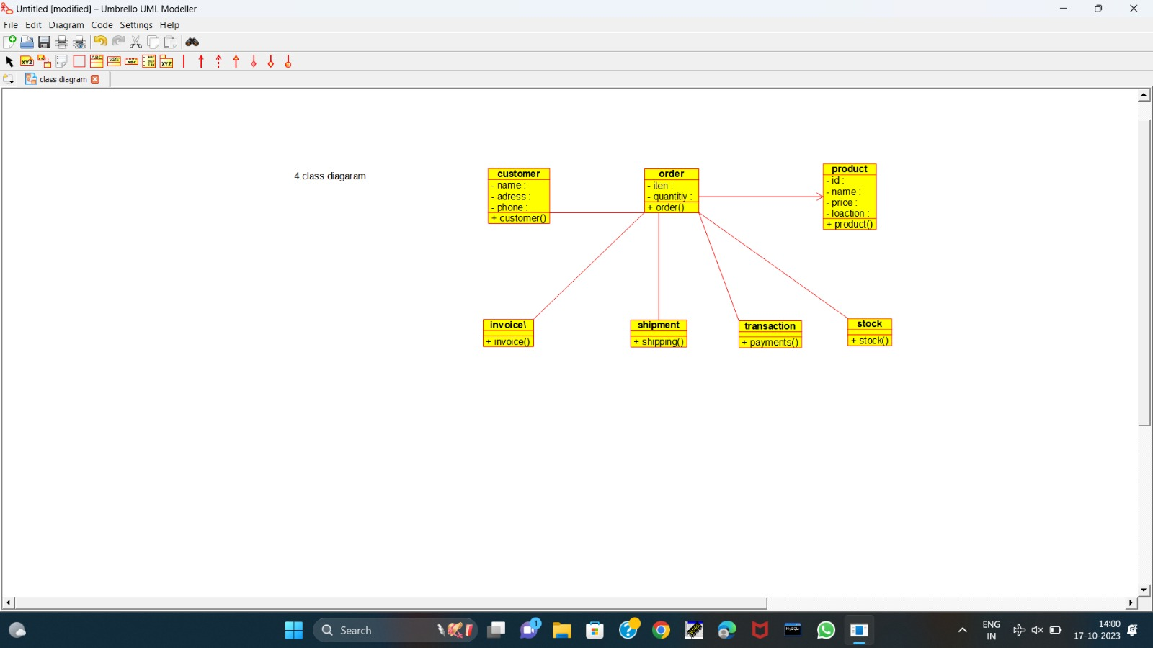

ACTIVITY DIAGRAM:

